**Hong Kong Institute of Vocational Education (ST) Department of Information Technology**

**The higher diploma of Software Engineering (IT114105)**

**Contemporary Topics in Software Engineering Assignment (ITP4507)**

**(2020/2021)**

Business Set Lunch Ordering System Report

We declare that this is a group project and that no part of this submission has been copied from any other student’s work or from any other source except where due acknowledgment is made explicitly in the text, nor has any part been written for us by another person.

|  |  |  |  |
| --- | --- | --- | --- |
| Student | Student No. | Contribution to the project(%) (Total 100%) | Signature |
| Lau Man Chun | 190382372 | 100% |  |

Table of Content

**Problem Context** **3**

**Assumptions** **4**

**Application Design** **5**

Entire Program Class diagram(with dependencies) 5

Entire Program Class diagram(without dependencies) 6

Class Diagram(Command Factory) 7

Class Diagram(Menu Factory, Lunch Set Factory) 7

Class Diagram(Command Pattern) 8

Class Diagram(Memento Pattern) 9

**Discussion and explanation of each of the design patterns applied to the application** **10**

Command patterns 10

Factory patterns 12

Memento Pattern 14

**User Guide** **15**

Installation 15

Program Manual 16

Edit Menu(Command “e”) 17

Show Menu(Command “s”) 18

Place Order(Command “p”) 19

List Outstanding Orders(Command “l”) 20

Complete Order(Command “d”) 20

Cancel Order(Command “c”). 20

**Test Plan and Test Cases** **21**

# Problem Context

A company has a staff canteen which provides catering service for its staff. Both eat-in and takeaway services are provided by the canteen. Recently, due to the COVID-19, restrictions about canteen accommodations for eat-in service have to be observed. The company management wants to encourage the staff to stay in the company for lunch in order to lower the risk of infection. Therefore, the company has decided to subsidize the canteen to provide low-price and high-quality Business Lunch Sets via a new ordering system called Business Set Lunch Ordering System (BSLOS). Staff can order Business Lunch Set at an attractive price and the canteen will deliver the meal to the staff office directly.

Initially, the company will provide two kinds of Business LunchSet: Chinese style and Western Style. The Chinese style set includes a main dish with rice, a cup of Chinese style soup, and a cup of Oolong tea(hot or iced). The Western-style set includes a main dish with one starch side dish which could be chosen from rice, spaghetti or French fries, a cup of Western-style soup, and a cup of coffee or tea(hot or iced). Only a limited number of lunch set of each style will be available each day. The main dish of each style of lunch set will be changed on each day and the price of a lunch set may also be changed depending on the main dish.

The menu will be available at 9:00 am every day, showing the details including the price and the available count. After viewing the menu, the staff can choose either the Chinese style or the Western-style and specify the relevant options, then enter staff number and office location to make an order. The available count will be updated accordingly when an order is received or cancelled. The orders will be handled on a first-come-first-served basis and the delivery will start at 1:00 PM.

BSLOS should provide the following functions:

1. Edit menu
2. Show menu(display lunch sets with available counts)
3. Make order
4. Cancel order
5. List outstanding orders (orders which have not been completed)
6. Mark order as completed

Required to apply the following patterns in the system design

* Command Pattern to provide the “Edit menu”, “Show menu”, “Make order”, “Cancel order”, “List outstanding orders”, “Mark order as completed” functions
* Factory Method or abstract Factory Pattern to create different kinds of Command objects and different kinds of Lunch Set.
* Memento Pattern to support the “Cancel order” function

# Assumptions

1. Recommended to use JDK15.0.1

java version "15.0.1" 2020-10-20

Java(TM) SE Runtime Environment (build 15.0.1+9-18)

Java HotSpot(TM) 64-Bit Server VM (build 15.0.1+9-18, mixed mode, sharing)

# Application Design

## Entire Program Class diagram(with dependencies)

# 

## Entire Program Class diagram(without dependencies)

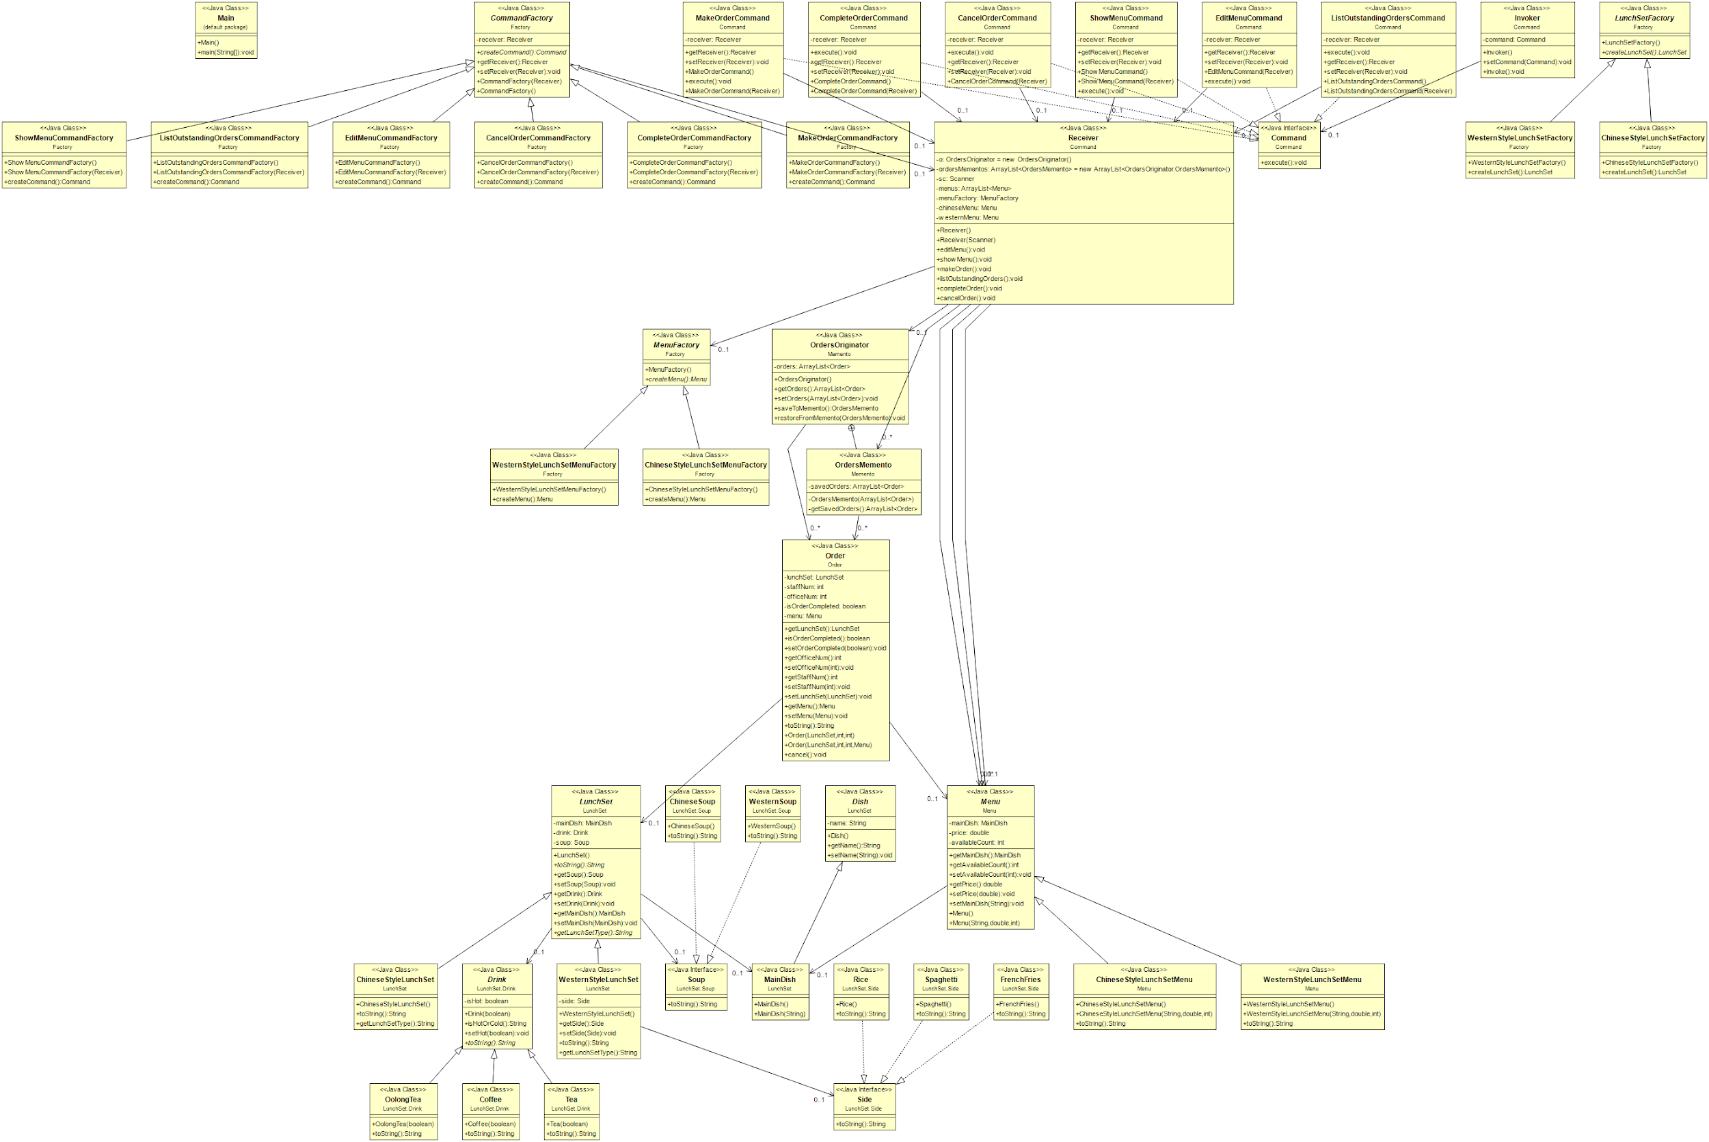

## Class Diagram(Command Factory)

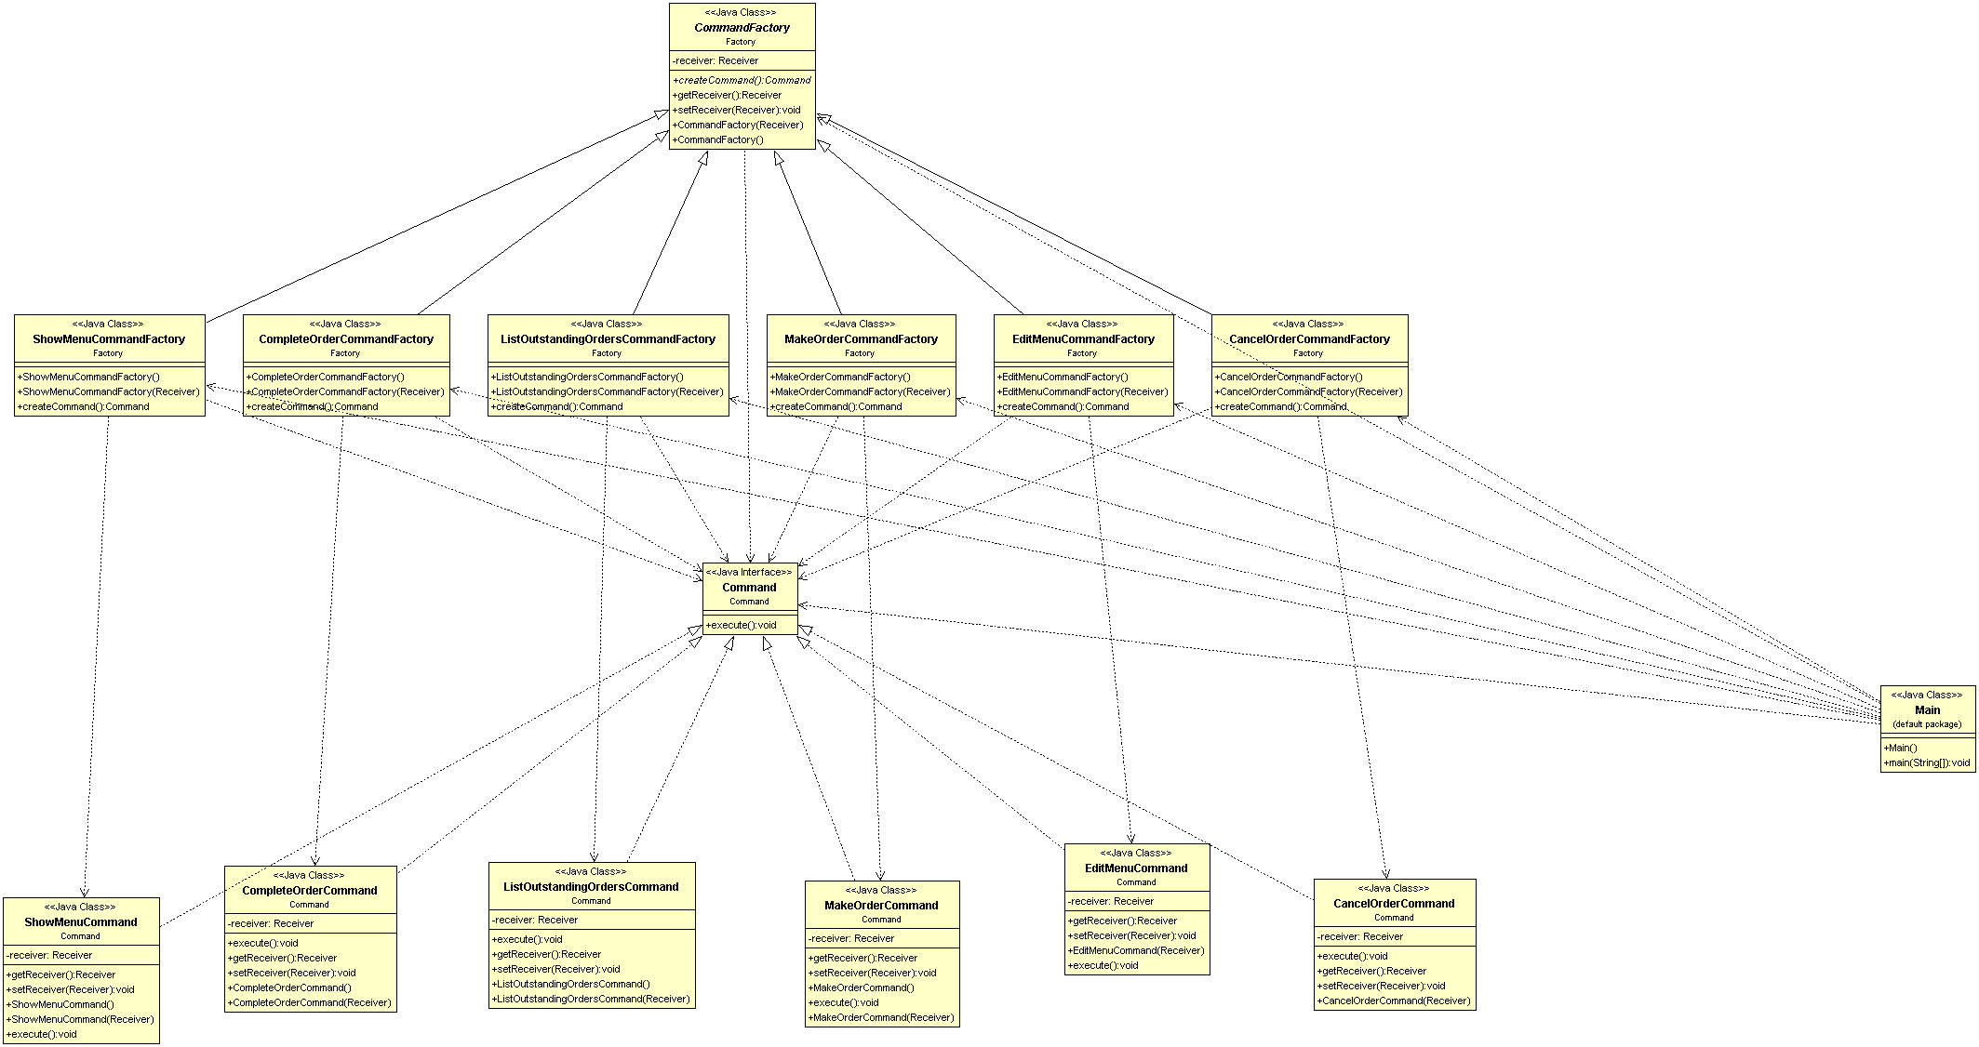

## Class Diagram(Menu Factory, Lunch Set Factory)

## 

## Class Diagram(Command Pattern)

## 

## 

## Class Diagram(Memento Pattern)

## 

# 

# Discussion and explanation of each of the design patterns applied to the application

## Command patterns

Command patterns are used for doing actions such as Edit menu, show menu, make order, list outstanding orders, etc. I design six classes which implement the Interface Command that provides one main method including execute. The name and description of the classes are shown below:

* EditMenuCommand

The EditMenuCommand defines a binding between the editMenu() and the Receiver. When the Invoker calls execute() the EditMenuCommand will run editMenu() on the Receiver

* ShowMenuCommand  
  The ShowMenuCommand defines a binding between the showMenu() and the Receiver. When the Invoker calls execute() the ShowMenuCommand will run showMenu() on the Receiver
* MakeOrderCommand  
  The ShowMenuCommand defines a binding between the makeOrder() and the Receiver. When the Invoker calls execute() the ShowMenuCommand will run makeOrder() on the Receiver
* ListOutstandingOrdersCommand  
  The ListOutstandingOrdersCommand defines a binding between the listOutstandingOrders() and the Receiver. When the Invoker calls execute() the ListOutstandingOrdersCommand will run listOutstandingOrders() on the Receiver
* CompleteOrderCommand  
  The CompleteOrderCommand defines a binding between the completeOrders() and the Receiver. When the Invoker calls execute() the ListOutstandingOrdersCommand will run completeOrders() on the Receiver
* CancelOrderCommand  
  The CancelOrderCommand defines a binding between the cancelOrders() and the Receiver. When the Invoker calls execute() the CancelOrderCommand will run cancelOrders() on the Receiver
* Invoker  
  The Invoker holds a command and can get the Command to execute a request by calling the execute method.
* Receiver  
  Used to performs the action(Edit Menu, Show Menu, Make Order, List Outstanding Orders, Complete Order, and Cancel Order)
* Command  
  The command is an object that encapsulates a request to the receiver. Command declares an interface for all commands, providing a simple execute() method which asks the Receiver of the command to carry out an operation.

|  |  |
| --- | --- |
| Invoker: | * Invoker |
| Command: | * Command |
| Receiver: | * Receiver |
| Concrete Command: | * EditMenuCommand * ShowMenuCommand * MakeOrderCommand * ListOutstandingOrdersCommand * CompleteOrderCommand * CancelOrderCommand |

## Factory patterns

Factory patterns are used to create different kinds of Command objects and different kinds of Lunch Set. The name and description of the classes are shown below:

* CommandFactory  
  Declares the factory method, which returns an object of type Command.
* EditMenuCommandFactory  
  Overrides the factory method to return an instance of an EditMenuCommand.
* ShowMenuCommandFactory  
  Overrides the factory method to return an instance of a Show Menu Command.
* MakeOrderCommandFactory  
  Overrides the factory method to return an instance of a MakeOrderCommand.
* ListOutstandingOrdersCommandFactory  
  Overrides the factory method to return an instance of a List Outstanding Orders Command.
* CompleteOrderCommandFactory  
  Overrides the factory method to return an instance of a CompleteOrderCommand.
* CancelOrderCommandFactory  
  Overrides the factory method to return an instance of a CancelOrderCommand.
* LunchSetFactory  
  Declares the factory method, which returns an object of type LunchSet(Chinese style lunch set / Western style lunch set)
* ChineseStyleLunchSetFactory  
  Overrides the factory method to return an instance of a ChineseStyleLunchSet.
* WesternStyleLunchSetFactory  
  Overrides the factory method to return an instance of a WesternStyleLunchSet.
* MenuFactory  
  Declares the factory method, which returns an object of type Menu(Chinese style lunch set menu / Western style lunch set menu)
* ChineseStyleLunchSetMenuFactory  
  Overrides the factory method to return an instance of a ChineseStyleLunchSetMenu.
* WesternStyleLunchSetMenuFactory  
  Overrides the factory method to return an instance of a WesternStyleLunchSetMenu

Command Factory

|  |  |
| --- | --- |
| Product: | * Command |
| Concrete Product: | * EditMenuCommand * ShowMenuCommand * MakeOrderCommand * ListOutstandingOrdersCommand * CompleteOrderCommand * CancelOrderCommand |
| Creator: | * CommandFactory |
| Concrete Creator: | * EditMenuCommandFactory * ShowMenuCommandFactory * MakeOrderCommandFactory * ListOutstandingOrdersCommandFactory * CompleteOrderCommandFactory * CancelOrderCommandFactory * ChineseStyleLunchSetFactory |

Lunch Set Factory

|  |  |
| --- | --- |
| Product: | * LunchSet |
| Concrete Product: | * ChineseStyleLunchSet * WesternStyleLunchSet * ChineseStyleLunchSetMenu * WesternStyleLunchSetMenu |
| Creator: | * LunchSetFactory * MenuFactory |
| Concrete Creator: | * ChineseStyleLunchSetFactory * WesternStyleLunchSetFactory * ChineseStyleLunchSetMenuFactory * WesternStyleLunchSetMenuFactory |

Menu Factory

|  |  |
| --- | --- |
| Product: | * Menu |
| Concrete Product: | * ChineseStyleLunchSetMenu * WesternStyleLunchSetMenu |
| Creator: | * MenuFactory |
| Concrete Creator: | * ChineseStyleLunchSetMenuFactory * WesternStyleLunchSetMenuFactory |

## Memento Pattern

Memento Pattern to support the “Cancel order” function. The name and description of the classes are shown below:

1. OrdersOriginator  
   Is the object whose state orders that we want and need to save.
2. OrdersMemento  
   Is another object that saves the orders of the OrdersOriginator.
3. Receiver  
   Manages the timing of the saving of the state, saves the OrdersMemento and, if needed, uses OrdersMemento to restore the state of the OrdersOriginator.

|  |  |
| --- | --- |
| Originator: | * OrdersOriginator |
| Memento: | * OrdersMemento |
| Caretaker: | * Receiver |

The system design conforms to the Open-Closed Principle so that the system can easily be extended to support new functions and the creation of new LunchSets, Soups and Drinks.

# User Guide

## Installation

Setup

$ cd ITP4507_Assignment

$ cd source code

$ javac @sources.txt

Run the program

$ java Main

(Or installation and run by using run.bat)

## Program Manual

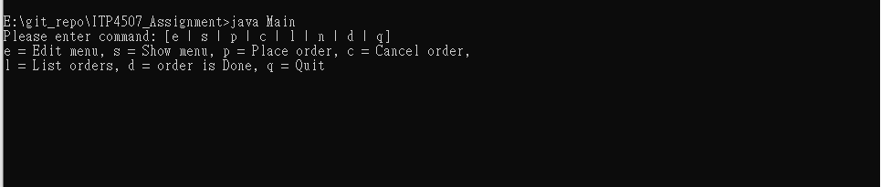

|  |  |
| --- | --- |
| Actions | Way |
| Edit Menu | Input e |
| Show Menu | Input s |
| Place Order | Input p |
| List Outstanding Orders | Input l |
| Complete Order | Input d |
| Exit System | Input q |

### Edit Menu(Command “e”)

* Press e to edit menu

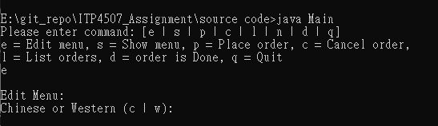

* When the user enters the corresponding command key “e”, the system will execute the edit menu command, the system will require the user to input “c” or “w” to select chinese or western style lunch set menu to edit.

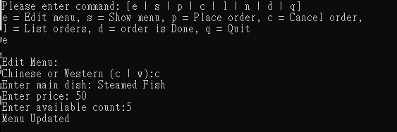

* If the user needs to edit chinese style lunch set menu, that he must enter the main dish name, price, and available count. After the edit menu success, the system will display “Menu Updated”.

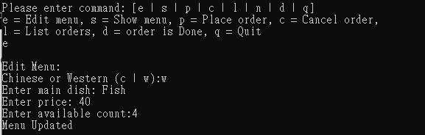

* If the user needs to edit chinese style lunch set menu, that he must enter the main dish name, price, and available count. After the edit menu success, the system will display “Menu Updated”.

### Show Menu(Command “s”)

* Press “s” to show menu

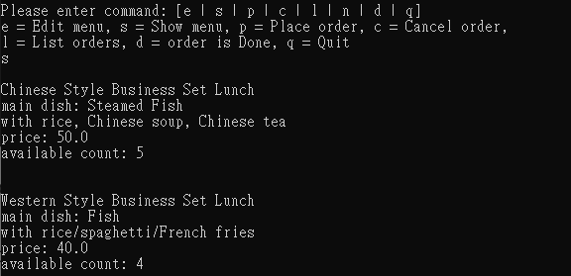

* When the user enter the corresponding command key “s”, the system will display all the menus(Chinese Style Lunch Set Menu, Western Style Lunch Set Menu)

### Place Order(Command “p”)

* Press “p” to Place Order

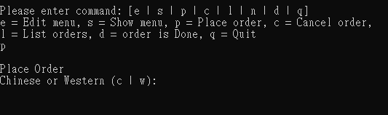

* When the user enters the corresponding command key “s”, the system will ask the user to input “c” or “w” to select chinese or western style lunch set menu to place order.

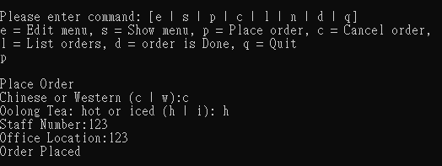

* If the user needs to place order of chinese style lunch set, input “c”, that user must enter the hot or iced Oolong Tea, staff number, and office location. After Place Order success, the system will display “Order Placed”.

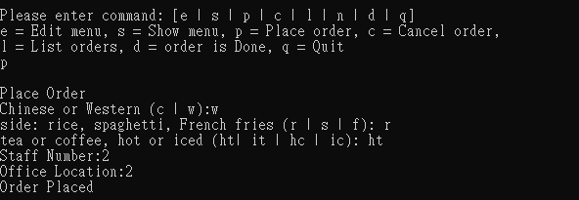

* If the user needs to place order of western style lunch set, input “w”, that user must enter the side(rice, spaghetti, french fries), tea or coffee, hot or iced, staff number, and office location. After Place Order success, the system will display “Order Placed”.

### List Outstanding Orders(Command “l”)

* Press “l” to List Outstanding Orders

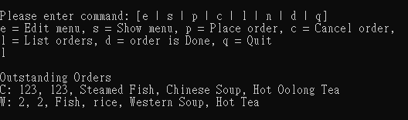

* When the user enters the corresponding command key “s”, the system will display all the orders with type of lunch set, staff number, office location, lunch set detail.

### Complete Order(Command “d”)

* Press “d” to Complete Order

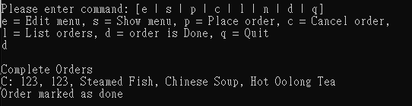

* When the user enters the corresponding command key “d”, the system will finish the first Outstanding Orders. After complete order success, the system will display “Order marked as done”.

### Cancel Order(Command “c”).

* Press “c” to Complete Order

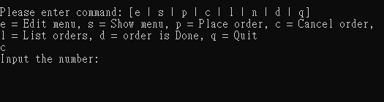

* When the user enters the corresponding command key “c”, the system will ask the user to input the staff number to cancel the order. After canceling order success, the system will display order detail and “Order Cancelled”.

# Test Plan and Test Cases

I will use Black Box Testing to test the system because the system is not complex.

Below are the test cases:

|  |  |
| --- | --- |
| Test case | Edit The Chinese Style Lunch Set Menu |
| Case ID | T01 |
| User | Staff |
| Test Flows | 1. Input e 2. Input c 3. Input Steamed Fish 4. Input 30 5. Input 3 |
| Input Data | 1. The command of Edit the Menu. 2. Type of the Menu 3. Information on the Menu. Main Dish, price, available count |
| Expected Results | The Menu has edited.  Display: |
| Pass/Fail | Pass |

|  |  |
| --- | --- |
| Test case | Edit The Western Style Lunch Set Menu |
| Case ID | T02 |
| User | Staff |
| Test Flows | 1. Input e 2. Input w 3. Input Steak 4. Input 40 5. Input 3 |
| Input Data | 1. The command of Edit the Menu. 2. Type of the Menu 3. Information on the Menu. Main Dish, price, available count |
| Expected Results | The Menu has edited.  Display: |
| Pass/Fail | Pass |

|  |  |
| --- | --- |
| Test case | Show Menu |
| Case ID | T03 |
| User | Staff |
| Test Flows | 1. Input s |
| Input Data | 1. The command of show menu |
| Expected Results | Show the Chinese and Western Lunch Set Menu  Display: |
| Pass/Fail | Pass |

## 

## 

|  |  |
| --- | --- |
| Test case | Place Order(Chinese Style Lunch Set, Hot Oolong Tea) |
| Case ID | T04 |
| User | Staff |
| Test Flows | 1. Input p 2. input c 3. input h 4. input 123 5. input 123 |
| Input Data | 1. The command of place order 2. Select Chinese Lunch Set 3. Select Hot Oolong Tea 4. Staff Number 5. Office Location |
| Expected Results | Place Order successful  Display: |
| Pass/Fail | Pass |

## 

|  |  |
| --- | --- |
| Test case | Place Order(Western Style Lunch Set, French fries, ice coffee) |
| Case ID | T05 |
| User | Staff |
| Test Flows | 1. input p 2. input w 3. input f 4. input ic 5. input 987 6. input 987 |
| Input Data | 1. The command of Place order 2. Western Lunch Set 3. Select Side(French fries) 4. Select Drink(ice coffee) 5. Enter Staff Number 6. Enter Office Location |
| Expected Results | Place Order successful  Display: |
| Pass/Fail | Pass |

## 

|  |  |
| --- | --- |
| Test case | Place Order(Sold Out) |
| Case ID | T06 |
| User | Staff |
| Test Flows | 1. input p 2. input c |
| Input Data | 1. The command of place order 2. select lunch set(Chinese) |
| Expected Results | Display Sold Out message  Display: |
| Pass/Fail | Pass |

## 

|  |  |
| --- | --- |
| Test case | Cancel Order |
| Case ID | T08 |
| User | Staff |
| Test Flows | 1. input l 2. input c 3. input 234 4. input l |
| Input Data | 1. The command of List Outstanding Orders 2. The command of the cancel order 3. enter the staff number to cancel the order 4. The command of List Outstanding Orders |
| Expected Results | Order Cancelled  List Outstanding Orders remove the order  Display: |
| Pass/Fail | Pass |

|  |  |
| --- | --- |
| Test case | List Outstanding Orders |
| Case ID | T09 |
| User | Staff |
| Test Flows | 1. input l |
| Input Data | 1. The command of the List Outstanding Orders |
| Expected Results | List all outstanding orders  Display: |
| Pass/Fail | Pass |

## 

|  |  |
| --- | --- |
| Test case | Complete Order |
| Case ID | T10 |
| User | Staff |
| Test Flows | 1. input l 2. input d 3. input l |
| Input Data | 1. The command of the List Outstanding Orders 2. The command of the Complete Order 3. The command of the List Outstanding Orders |
| Expected Results | Complete the order  List Outstanding Orders remove the order  Display: |
| Pass/Fail | Pass |

## 

## 

|  |  |
| --- | --- |
| Test case | Place Order(Chinese Style Lunch Set, Iced Oolong Tea) |
| Case ID | T11 |
| User | Staff |
| Test Flows | 1. Input p 2. input c 3. input i 4. input 1 5. input 1 6. input l |
| Input Data | 1. The command of place order 2. Select Chinese Lunch Set 3. Select Iced Oolong Tea 4. Staff Number 5. Office Location 6. The command of the List Outstanding Orders |
| Expected Results | Place Order successful  List Outstanding Orders have the order  Display: |
| Pass/Fail | Pass |

|  |  |
| --- | --- |
| Test case | Place Order(Western Style Lunch Set, rice, hot tea) |
| Case ID | T12 |
| User | Staff |
| Test Flows | 1. input p 2. input w 3. input r 4. input ht 5. input 2 6. input 2 7. input l |
| Input Data | 1. The command of Place order 2. Western Lunch Set 3. Select Side(rice) 4. Select Drink(hot tea) 5. Enter Staff Number 6. Enter Office Location 7. The command of the List Outstanding Orders |
| Expected Results | Place Order successful  List Outstanding Orders have the order  Display: |
| Pass/Fail | Pass |

|  |  |
| --- | --- |
| Test case | Place Order(Western Style Lunch Set, spaghetti, iced tea) |
| Case ID | T13 |
| User | Staff |
| Test Flows | 1. input p 2. input w 3. input s 4. input it 5. input 3 6. input 3 7. input l |
| Input Data | 1. The command of Place order 2. Western Lunch Set 3. Select Side(spaghetti) 4. Select Drink(iced tea) 5. Enter Staff Number 6. Enter Office Location 7. The command of the List Outstanding Orders |
| Expected Results | Place Order successful  List Outstanding Orders have the order  Display: |
| Pass/Fail | Pass |

|  |  |
| --- | --- |
| Test case | Place Order(Western Style Lunch Set, spaghetti, hot coffee) |
| Case ID | T14 |
| User | Staff |
| Test Flows | 1. input p 2. input w 3. input s 4. input hc 5. input 4 6. input 4 7. input l |
| Input Data | 1. The command of Place order 2. Western Lunch Set 3. Select Side(spaghetti) 4. Select Drink(hot coffee) 5. Enter Staff Number 6. Enter Office Location 7. The command of the List Outstanding Orders |
| Expected Results | Place Order successful  List Outstanding Orders have the order  Display: |
| Pass/Fail | Pass |

|  |  |
| --- | --- |
| Test case | Input Invalid Option |
| Case ID | T15 |
| User | Staff |
| Test Flows | 1. Input f |
| Input Data | 1. Invalid Option |
| Expected Results | Output Invalid Option  Display: |
| Pass/Fail | Pass |

|  |  |
| --- | --- |
| Test case | Place Order Invalid Option |
| Case ID | T16 |
| User | Staff |
| Test Flows | 1. Input f |
| Input Data | 1. Invalid Option |
| Expected Results | Output Invalid Option  Display: |
| Pass/Fail | Pass |

## 

|  |  |
| --- | --- |
| Test case | Place Order repeat order staff reject |
| Case ID | T17 |
| User | Staff |
| Test Flows | 1. Input p 2. Input c 3. Input h 4. input 123 |
| Input Data | 1. The command of place order 2. Select Chinese Lunch Set 3. Select Hot Oolong Tea 4. Staff Number |
| Expected Results | Output Staff is ordered!!  Display: |
| Pass/Fail | Pass |